

IT Security Master Program

Department of Economic Informatics and Cybernetics

Faculty of Cybernetics, Statistics and Economic Informatics

Bucharest University of Economic Studies

Dissertation Thesis

Coordinator: Master Student:
Prof. Cristian Toma Ph.D. Marius-Remus Dumitrel

Bucharest 2026


IT Security Master Program

Department of Economic Informatics and Cybernetics

Faculty of Cybernetics, Statistics and Economic Informatics

Bucharest University of Economic Studies

A Decentralized Authentication Framework for IoT Devices Using Lightweight Blockchain Architecture

Dissertation Thesis

Coordinator: Master Student:
Prof. Cristian Toma Ph.D. Marius-Remus Dumitrel

Bucharest 2026

Statement regarding the originality of the content

I hereby declare that the results presented in this paper are entirely the result of my own creation unless reference is made to the results of other authors. I confirm that any material used from other sources (magazines, books, articles, and Internet sites) is clearly referenced in the paper and is indicated in the bibliographic reference list.

Submitted in partial fulfillment of the requirements for the degree of Master of Science in Cybersecurity

Abstract
The rapid proliferation of Internet of Things (IoT) devices has introduced significant challenges in identity management and authentication, particularly in distributed environments where centralized authorities represent single points of failure and attractive targets for adversaries. This thesis proposes, implements, and evaluates a decentralized authentication framework tailored for resource-constrained IoT devices, leveraging the lightweight, permissioned blockchain architecture of Hyperledger Fabric. The primary objective is to eliminate reliance on centralized trust anchors while providing an immutable, auditable record of device identity throughout its lifecycle.

To align with structural constraints typical of low-power IoT environments (minimal RAM and constrained battery life), the framework avoids computationally heavy consensus mechanisms like Proof-of-Work. Instead, it employs a challenge-response authentication protocol based on the Elliptic Curve Digital Signature Algorithm (ECDSA) over the secp256r1 curve, ensuring high cryptographic strength with low processing overhead. Each device generates a unique key pair natively; the public key is subsequently registered on the distributed ledger via a Hyperledger Fabric smart contract (chaincode). Authentication is achieved by issuing a randomized nonce challenge, which the device signs. The smart contract validates this signature exclusively on-chain, effectively mitigating common IoT attack vectors such as replay, spoofing, and Sybil attacks.

The system architecture was fully implemented and validated using a React-based frontend dashboard for real-time monitoring and administrative oversight, a Node.js middleware layer handling the Fabric Gateway SDK, and a robust TypeScript chaincode deployed on a Hyperledger Fabric test network. Experimental scenarios demonstrated successful end-to-end device registration, cryptographic challenge-response authentication utilizing the native Web Crypto API, and deterministic device access revocation, all executing reliably and verifiable natively on the distributed ledger. The developed prototype validates that permissioned blockchain technology can effectively decentralize and secure IoT authentication without compromising operational performance or resource efficiency.

Table of Contents:
Abstract iv
Table of Contents: v
List of Figures vi
Chapter 1: Introduction 1
1.1 Context and Problem Statement 1
1.2 Motivation 1
1.3 Thesis Objectives 2
1.4 Industry Context and Case Studies 3
1.5 Research Methodology 3
1.6 Document Structure 3
Chapter 2: State of the Art & Theoretical Foundation 4
2.1 Traditional IoT Security Models 4
2.2 Blockchain in IoT 4
2.3 Hyperledger Fabric Architecture 5
2.4 Cryptography on the Edge 6
2.5 Edge and Fog Computing Paradigms 6
2.6 Comparative Analysis of IoT Blockchain Frameworks 7
Chapter 3: Proposed Security Architecture 8
3.1 High-Level System Architecture 8
3.2 Threat Model and Trust Boundaries 10
3.3 Cryptographic Challenge-Response Protocol 11
3.4 Chaincode Architecture and Chaincode Device Lifecycle 12
Chapter 4: System Implementation 15
4.1 Hyperledger Fabric Setup 15
4.2 Dual-Protocol Middleware Gateways 18
4.3 The Simulation Strategy (Hardware vs. Software) 20
4.3.1 The QEMU ARM Emulator: 20
4.3.2 The Docker Fleet: 21
4.4 Administrative Dashboard 21
Chapter 5: Experimental Results and Performance Analysis 22
5.1 Evaluation Methodology 22
5.2 Cryptographic Overhead Analysis 22
5.3 Network Scalability and Payload Efficiency 22
5.4 Resilience to Network Failures 22
Chapter 6: Conclusions and Future Work 22
6.1 Conclusion 22
6.2 Future Work 22
References 23
Appendices 25
Appendix A: Smart Contract Source Code 25
Appendix B: API Routes and Middleware Logic 27
Appendix C: Emulation Configuration 30

List of Figures
Figure 1. The Execute-Order-Validate transaction flow in Hyperledger Fabric. Adapted from Androulaki et al. [9]. 5
Figure 2. System Architecture Component Diagram 8
Figure 3. System Architecture Diagram recreated with Gemini 9
Figure 4. Threat Model and Trust Boundaries flowchart 10
Figure 5. Authentication Sequence Diagram (with Application-Layer Security) 11
Figure 6. DeviceAuthContract chaincode Class Diagram 13

No table of figures entries found.

Chapter 1: Introduction

Context and Problem Statement
In the modern world, new advancements like connecting physical devices to the internet has fundamentally changed how we interact with our environment. From smart TVs, robotic vacuum cleaners, or even smart lightbulbs in our homes to industrial sensors and actuators on factory floors, the Internet of Things (IoT) is now everywhere around us. But this recent explosive growth hides a massive vulnerability: how we manage to secure these devices. Before a temperature sensor can push its data to a cloud dashboard or before a remote actuator accepts a command to shut off a door or water valve, the network needs to know exactly who is talking. What is the identity of the device sending or receiving the message? This is the core problem of device authentication.
Right now, the standard for the vast majority of IoT deployments is to handle authentication using a centralized model. Usually, this means we have a single remote server that holds a massive database of usernames, passwords, or public keys. When a device wakes up, it pings this server to prove its identity [1]. While this works well enough for web browsers, it creates a dangerous architectural flaw for physical infrastructure: an absolute single point of failure (SPOF) [2].
If this central server crashes or becomes unusable, for example if an attacker floods it with traffic in a Distributed Denial of Service (DDoS) attack, the entire fleet of devices goes offline. The smart devices relaying on the server as a „trust authority” simply have no other way to verify themselves. Even worse, if a hacker breaches that single database, they instantly compromise and have access to the identities of thousands of devices. This naturally makes such centralized databases a high-value target for attacks, such as identity spoofing or replay attacks. In a world where IoT devices control critical infrastructure, relying on a single, vulnerable server for network access is a risk we can no longer afford to take [3].

Motivation
I chose to tackle the specific problem of IoT device authentication because while the edge computing landscape is changing fast, most security protocols for IoT are struggling to keep up. This is also a result of the very heterogeneous (as in different) nature of IoT devices. Since IoT devices have a large pool of providers and their specifications can be very different as a result, there is a clear lack of standards when it comes to most aspects of the IoT „world”, as it is also pointed by Stefanescu and others [4]. To solve this device identity problem, we need to find a way to authenticate devices securely without bottlenecking them through a single server.
Blockchain technology caught my attention early in this research because it completely removes the need for centralized trust [4]. However, public blockchains like Bitcoin [5] or Ethereum [6] were not built for tiny, battery-powered, memory limited sensors and actuators. They require massive computational power (like in Bitcoin’s Proof of Work consensus) and charge unpredictable transaction fees (like in Ethereum’s Proof of Stake consensus), which makes them practically useless for a smart home or a remote factory [7]. Such reliance on a digital coin is unnecessary and even undesirable for an enterprise level IoT system.
This research is motivated by the idea that we can bridge this gap. By using a lightweight, permissioned blockchain, specifically Hyperledger Fabric [8], we can achieve the security and resilience of decentralized trust without demanding too much from the limited CPUs of legacy IoT hardware [9]. The goal is to build a system where trust is distributed across multiple gateway nodes rather than hoarded by a single authority.

Thesis Objectives
The main objective of this thesis is to design, implement, and rigorously test a decentralized authentication framework created and customized specifically for realistic resource-constrained IoT devices.
To prove that my architecture is actually viable in the real world, this project focuses on three specific goals:
1. Eliminate the Single Point of Failure: I will build a Multi-Gateway architecture where devices can authenticate against a distributed ledger, while ensuring the network stays up even if an individual gateway goes offline or becomes unavailable.
2. Push Security to the Edge: A cryptographic Challenge-Response protocol will be implemented using Elliptic Curve Cryptography [10] (the ECDSA secp256r1 curve will be used) and Application-Layer Security (ECDH + AES-256-CBC). These fundamental cryptographic concepts and algorithms are properly presented by Ivan and Toma in their handbook [11]. This protocol keeps private keys isolated on the devices and protects against eavesdropping, without overwhelming legacy hardware.
3. Design an on-chain device lifecycle: I will use a Smart Contract (chaincode in Fabric) to enforce a 4-state finite state machine directly on the blockchain. This contract will ensure that devices are in their proper state for data manipulation, for example a revoked device will not be able to authenticate again, but a suspended device should be able to. This implementation will also protect us from privilege escalation attacks, together with other security measures.
4. Prove Hardware Viability: I won't just simulate the network in software. A key objective is to run these cryptographic handshakes inside an emulated legacy ARMv7 processor (QEMU) to capture the true latency and hardware constraints that physical edge sensors face.

Industry Context and Case Studies
Past events show us the dangers of centralized authentication are not just theoretical. In 2016, the Mirai Botnet provided a terrifying look at what happens when IoT security fails at scale. Mirai infected hundreds of thousands of IP cameras and home routers simply by guessing their default hardcoded credentials [12]. Once infected these devices were weaponized to launch a massive DDoS attack that took down large sections of the internet. If those devices had required a cryptographic decentralized authentication handshake the attack would have been mathematically impossible [13].
This kind of vulnerability is especially critical in domains like the modern automated industry, government institutions or smart healthcare. In a hospital, manipulating a compromised sensor or actuator is not just a nuisance; it is a life-threatening failure. Critical infrastructure that needs to be permanently active and available is a great target for ransomware attacks, as shown by many recent attacks on hospitals and government institutions in the USA, but also in Romania (the ANAF website). By moving trust to the edge and requiring cryptographic proof for every interaction, we can protect these critical sectors from the next iteration of Mirai.

Research Methodology
To achieve the objectives outlined above, my research was conducted in four distinct phases:
1. Literature Review: I have analyzed the current state of IoT authentication and the theoretical boundaries and implementations of lightweight blockchains.
2. Architectural Design: Planning my implementation by designing the Multi-Gateway architecture and the Smart Contract State Machine.
3. Implementation: Actually coding the Hyperledger Fabric chaincode in TypeScript (the DeviceAuthContract) and building the Node.js [14] API middleware and the React [15] frontend for visualization.
4. Testing and Evaluation: By deploying the system across a hybrid environment consisting of x86 Docker containers (which are using my computer’s processor) and a QEMU ARMv7 emulator (a special Docker container simulating an ARM processor) to benchmark and compare real-world cryptographic overhead, key generation timings and network latency.

Document Structure
The following chapters of this thesis are organized to walk through the problem, the proposed solution, and the testing results.
In chapter 2, I explain the current state of the art for IoT & blockchain integration, detailing why traditional IoT security fails and how lightweight blockchains offer us a way forward.
Chapter 3 outlines my proposed security architecture, including the specific threat model (how the model handles Sybil and Replay attacks) and the smart contract lifecycle.
Chapter 4 dives into the technical implementation. It breaks down the Hyperledger Fabric setup, the Node.js middleware gateways, and the dual-simulation strategy using Docker and QEMU.
In chapter 5, I present the experimental results. I will analyze the hard latency numbers, comparing the cryptographic overhead of modern x86 processors against constrained ARM emulators, in order to prove this framework's viability.
Finally, Chapter 6 summarizes the conclusions drawn from my research, this framework’s limitations, and outlines areas for future development, including hardware-based root of trust or post-quantum security algorithms.

Chapter 2: State of the Art & Theoretical Foundation

2.1 Traditional IoT Security Models
The standard way we secure internet traffic today relies heavily on Public Key Infrastructure (PKI) and protocols like TLS or OAuth, which are explained in [11]. These work very well when used for advanced computers like laptops or smartphones, but they break down when applied to cheap, resource limited IoT devices. Devices running on legacy ARM processors or running off small batteries often cannot handle the heavy computational load required to establish a full TLS handshake [16].
Because full PKI is too heavy for such an environment, developers often take shortcuts. They hardcode passwords or use static API tokens that never change. They then store all these tokens in a massive centralized database [2]. If a hacker manages to extract a static token from just one poorly secured sensor, they can often compromise the entire system [17]. The traditional model forces us into a bad compromise: we either burn through the device's battery and processing power with heavy encryption or we rely on weak static passwords stored in a centralized database that is vulnerable to many forms of attacks.

2.2 Blockchain in IoT
Blockchain technology naturally emerged as the obvious alternative to centralized databases. By distributing the ledger across multiple nodes, we can completely eliminate this single point of failure. A hacker cannot take down the network by attacking just one server because every node holds a copy of the truth [18].
Dorri et al. demonstrated that coupling lightweight blockchain ledgers with IoT gateways can eliminate centralized bottlenecks and provide auditable device-to-device communication trails [19]. Christidis and Devetsikiotis further showed that smart contracts can automate security policies directly on the distributed ledger [20]. Stefanescu et al. conducted a systematic literature review covering many recent developments, noting a lack of evaluation standards and a clear trend toward offloading complex cryptographic operations from the IoT node to edge gateways or the ledger itself [4]. Stefanescu also pointed that while decentralization mitigates single points of failure (SpoFs), traditional consesnus mechanisms tend to introduce prohibitive latency costs.

Unsurprisingly, trying to force traditional blockchains into an IoT environment introduced a whole new set of problems. Early research often looked at public blockchains like Bitcoin [5] or Ethereum [6]. These networks use consensus mechanisms like Proof of Work which requires massive amounts of computational power to solve computationally heavy cryptographic puzzles. A Raspberry Pi or a smart thermostat simply does not have the processing power to mine blocks or pay the volatile transaction fees required to interact with these public networks. We need the decentralization of a blockchain, but without such a heavy consensus overhead.

2.3 Hyperledger Fabric Architecture
Among the large variety of options, permissioned ledgers like Hyperledger Fabric created especially for enterprise IoT, seem to address the trade-off of security vs computational cost in the most optimal way, whilst maintaining real-world applicability. Unlike public blockchain networks, Fabric is private. You have to be explicitly invited and authorized to join its network [9]. This private nature specific to permissioned blockchains allows for a certain level of trust on which faster and more efficient consensus algorithms can be built. As presented above, most public blockchains use a heavy Byzantine fault tolerant (BFT) consensus, usually dependent on a crypto-currency and transaction fees, where all nodes execute transactions before they can be registered on the ledger. Fabric has a modular and layered structure, which allows it to separate concerns so that transactions are endorsed only by specific peers and ordered using a Crash fault tolerant (CFT) consensus with a Raft based ordering service [9]. In essence, Fabric works as a distributed operating system capable of executing smart contracts (chaincode) in common programming languages (Go, Node.js, Java) with deterministic outcomes and without the need for a native crypto-currency.

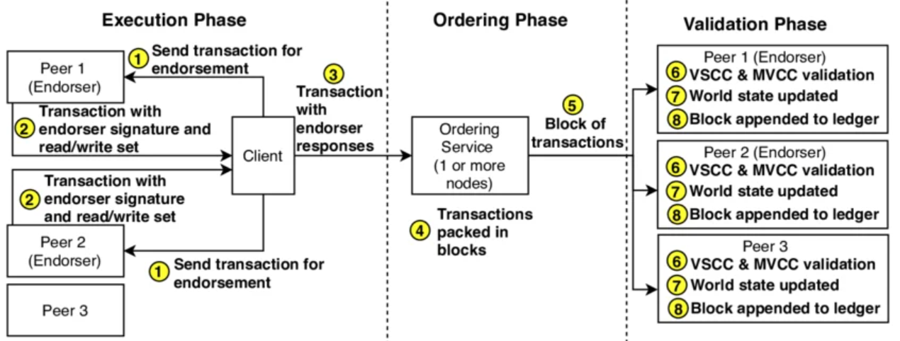
Figure 1. The Execute-Order-Validate transaction flow in Hyperledger Fabric. Adapted from Androulaki et al. [9].
What makes Fabric perfect for this thesis is its unique Execute-Order-Validate architecture, which can be seen in Figure 1. In traditional blockchains, which usually use an Order-Execute architecture, every node has to execute every transaction before it can be added to the block. Fabric separates this process. It allows specific "Endorsing Peers" to execute the transaction first and then sends the results to an "Ordering Service" [8]. For this project I am using the Raft [21] consensus mechanism for the ordering service, backed by a distributed ‘etcd’ cluster [22]. Raft is crash fault tolerant (CFT) and doesn't require any heavy mining. It simply elects a leader to order the transactions and distributes them to the network. This modular approach means we can achieve incredibly fast transaction finality without asking the IoT devices to do any of the heavy lifting. Gorenflo et al. [23] proved Fabric’s efficiency and potential scalability, by implementing “FastFabric”, an optimized configuration capable of handling up to 20,000 transactions per second.

2.4 Cryptography on the Edge
Even with a lightweight blockchain, we still have to prove that a specific device is the one actually sending the message. This requires cryptography. Instead of using older algorithms like RSA which require massive key sizes to be secure, I implemented Elliptic Curve Cryptography (ECC) [10] which is better suited for resource constrained devices. With ECC, the devices will have a smaller payload and faster signature generation time.

Specifically, this project uses the ECDSA secp256r1 curve. Elliptic curves provide the exact same level of security as RSA, but with much smaller key sizes [24]. This is a massive advantage when working with the limited memory of legacy ARM processors. To protect the payload data from being intercepted over the air, I also implemented an Application-Layer Security model. The device and the gateway perform an Elliptic Curve Diffie-Hellman (ECDH) key exchange to agree on a shared secret and then use AES-256-CBC to encrypt the actual payload [14]. This ensures that even if someone is sniffing the Wi-Fi or packet traffic, all they can see is encrypted noise.

2.5 Edge and Fog Computing Paradigms
Before further discussing the system’s performance, it is important to clearly define where the authentication logic of my project actually lives. In traditional cloud computing, data is usually generated at the edge and sent all the way to a central control system, like a cloud server, for processing. This process introduces unacceptable latency costs for real-time IoT devices, potential availability issues, and heavy data privacy concerns.
To solve this, researchers introduced Fog Computing. Fog computing acts as an intermediary layer, pulling the computational power closer to the edge without forcing the tiny IoT devices to do all the work [25]. In this thesis, my Node.js Multi-Gateways will function perfectly as Fog Nodes [26]. They handle the heavy gRPC communication with the Fabic network and assist the complex blockchain consensus logic, effectively shielding the constrained IoT sensors from the computational burden.

2.6 Comparative Analysis of IoT Blockchain Frameworks
When choosing a blockchain, or better said a Distributed Ledger Technology (DLT), for this project, I did not just default to Hyperledger Fabric. To make the best choice, it was essential to examine other recent approaches and implementations, to understand their limitations and architectural trade-offs.
For example, the literature heavily discusses Directed Acyclic Graphs (DAGs) like IOTA as an alternative option, which were built specifically for IoT environments [27]. IOTA uses a Tangle structure where each new transaction must verify two previous transactions, allowing it to theoretically scale infinitely without fees. However, while IOTA excels at micro-transactions, it lacks the strict, robust access control required for enterprise authentication [28]. IOTA is a public permissionless network. For device authentication, we need absolute deterministic control over who is allowed to join the network and who is permanently revoked. Hyperledger Fabric's permissioned channel architecture and its crash-fault tolerant Raft ordering service provide this exact level of enterprise control [27]. It gives us the decentralized trust of a blockchain, but the strict access governance of a private corporate network.
Even though other authors have proposed lightweight blockchain architecture frameworks for edge computing, for example “FogBus” [29] and “LightChain” [30], their implementations still expect considerable computational power from the actual IoT devices. Similarly, Zhao et al. [31] developed an authentication mechanism tailored for the Industrial Internet of Things (IIoT) to minimize cryptographic burdens. Yet, many such custom consensus mechanism implementations rely on protocols that lack the enterprise-grade stability of established frameworks like Hyperledger Fabric, like its crash-fault tolerance and strict cross-organization access control. Bandara et al. [32] in his “Tikiri” framework explored verification awareness in lightweight blockchains to optimize consensus and reduce overhead, but their methodology exposes potential scalability limits under high-density concurrent requests.

In another recent work, Villegas-Ch et al. [17] proposed a lightweight blockchain for authentication in constrained networks. However, their architecture relies heavily on MQTT (Message Queuing Telemetry Transport) for communication between the edge nodes and the central gateway. While MQTT is a lightweight publish-subscribe protocol, it requires a centralized broker to manage the message routing. If this central broker fails, the entire local network segment goes offline, directly contradicting my goal of true decentralization. In contrast, the approach proposed in this thesis utilizes CoAP (Constrained Application Protocol) and HTTP over a Multi-Gateway architecture [33]. By communicating directly with decentralized Fog gateways without an intermediary broker, we eliminate the single point of failure that plagues MQTT-based systems. Using MQTT for the resource constrained edge communication is also very inefficient, at least a specialized alternative like MQTT-SN (Sensor Networks) should have been used instead.

My approach differs by using the gateway middleware as a translation bridge, which handles the heavy communication to the blockchain. The gateways are stateless and easily replicable, the authentication logic is not dependent on any particular gateway node. The heavy cryptographic computations and storage are managed by the blockchain, at the smart contract (chaincode) level. The private keys never leave the devices and only lightweight payload security is done at the device level.

Chapter 3: Proposed Security Architecture

3.1 High-Level System Architecture
When building any complex network, the "High-Level System Architecture" serves as the macroscopic blueprint. This blueprint will define the major physical and logical components contained in our ecosystem, such as: the edge devices, the intermediate middleware and the backend database. It will also explain how data flows between this project’s components. In traditional setups, this architecture usually resembles a centralized hub (like a hub-and-spoke model) with multiple workflows pointing to a single server.
To achieve true decentralization, the architecture proposed in this thesis breaks away from using such a centralized hub format. I designed a Multi-Gateway model where IoT devices are never bound to a single point of failure. Instead, they can freely communicate with multiple independent organization gateways (such as Org1 or Org2 from Fabric’s test network). From the literature, we can observe these gateways function as Fog nodes. By using them to push the heavy cryptographic workload and consensus logic closer to the edge, we can keep the network decentralized while actively shielding the constrained sensors from computational burnout.

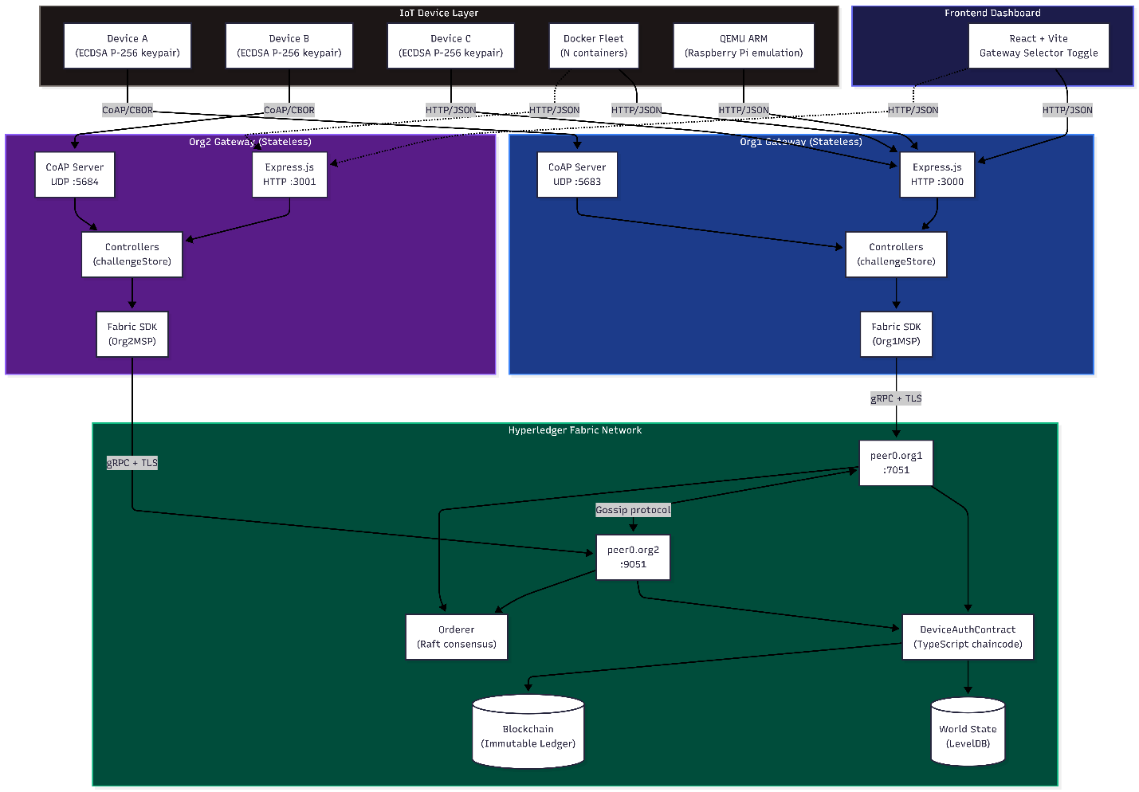
Figure 2. System Architecture Component Diagram
Figure 2 visually maps out this deployment topology. As the diagram illustrates, the physical edge devices are completely separated from the core Fabric ledger. Whether a node is a simple browser emulator or a resource-constrained QEMU ARM instance, it connects to the network via HTTP or CoAP through a distinct organizational gateway. The diagram highlights how these gateways absorb and package the complex gRPC communication required by the Hyperledger Fabric SDK. Meanwhile, the Fabric network operates securely in the background using LevelDB (actually CouchDB for this project’s test network) backed peer nodes and a Raft consensus based Orderer node to maintain a synchronized global state.
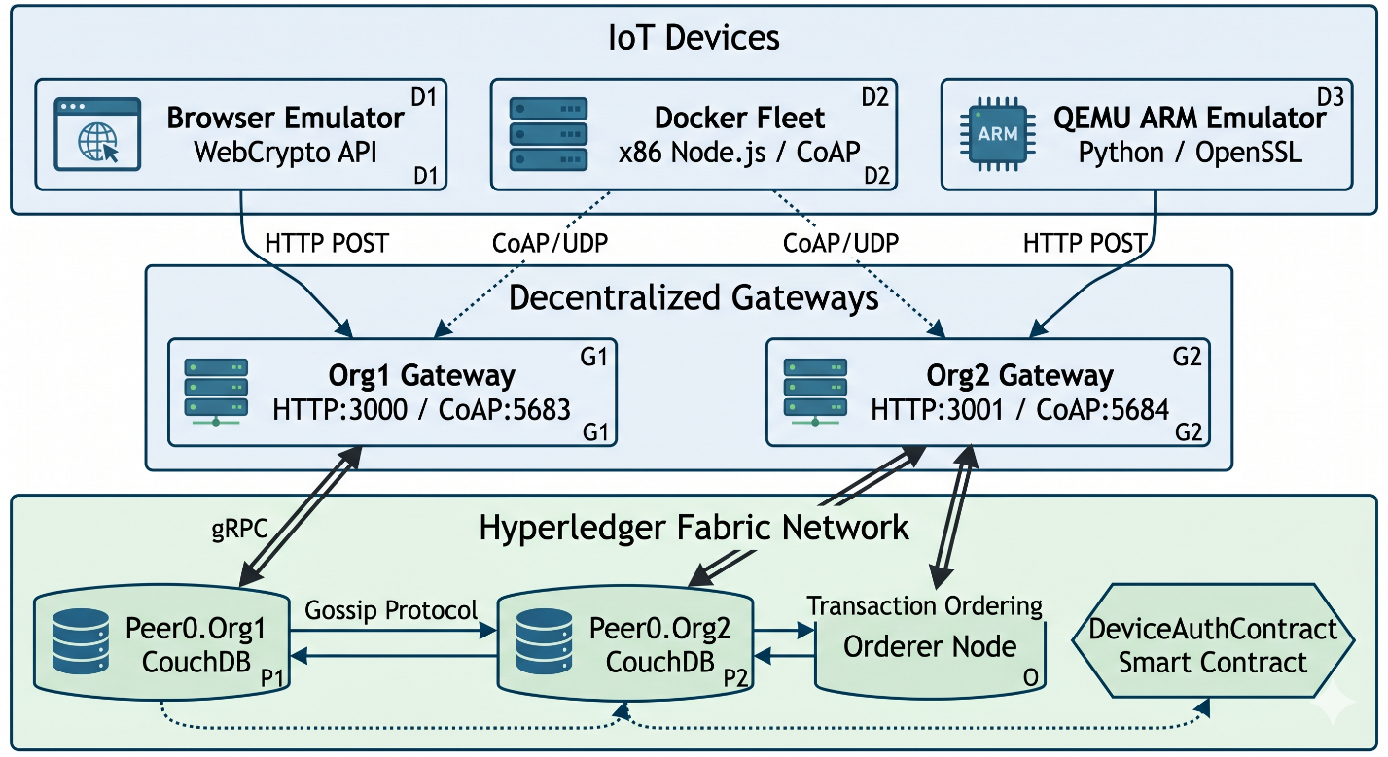
Figure 3. System Architecture Diagram recreated with Gemini
Based on the UML component diagram in Figure 2, I have created a simpler illustration in Figure 3, showing exactly how my proposed framework operates and what device simulation and testing environments have been used during the implementation stage.
Notice the 3 core layers that compose my architecture: the device layer, the gateway (or middleware) layer, and the Fabric blockchain layer. The CouchDB database used by Fabric to store the world state, together with our DeviceAuthContract smart contract’s logic that manages device states on it, could also be considered as a hidden 4th layer. The Frontend Dashboard used for live interaction and visualization acts in many ways as just another device layer component with special permissions. The utility, interaction, and implementation of these layers will be further discussed in the following chapters and sub-chapters. For now, what’s important to remember is how the communication flow decouples the heavy cryptographic operations from the resource constrained edge devices. The burden of maintaining the state, validating signatures, and storing identity records is offloaded entirely to the distributed ledger’s smart contract (chaincode). This ensures that even if other layers are compromised, the fundamental identities and access privileges of the IoT devices remain anchored on the immutable blockchain ledger.

3.2 Threat Model and Trust Boundaries
We cannot secure our system until we understand exactly how it can be attacked. A "Threat Model" is essentially a structured exercise in paranoia; it tries to identify every potential attack vector an adversary might exploit. Coupled with this is the concept of "Trust Boundaries" which define the exact perimeters where data transitions from an insecure, unverified state into a protected, trusted zone.
In the context of this research, we have to assume the physical IoT device exists in a purely hostile environment. Out in the field, leaf devices like temperature sensors are highly vulnerable to physical tampering and wireless network sniffing. Malicious actors could attempt such side-channel attacks or brute-force operations against the physical edge devices lacking dedicated hardware secure elements. Since hardware security is not currently part of the scope of this thesis, we simply have to assume that some edge devices could become compromised.
Through its architecture, our system is already designed to withstand several common attack patterns targeting IoT deployments. The most obvious one being Distributed Denial-of-Service (DDoS) attacks targeting the centralized credential authorities. Since we do not have such a centralized authority and our devices can authenticate using different organizational gateways, our system is naturally resistant to such forms of attack. Even if a gateway fails, others can simply take its place. However, other forms of attacks still exist, and we must take special precautions against them, like using a nonce, timestamps and payload security.
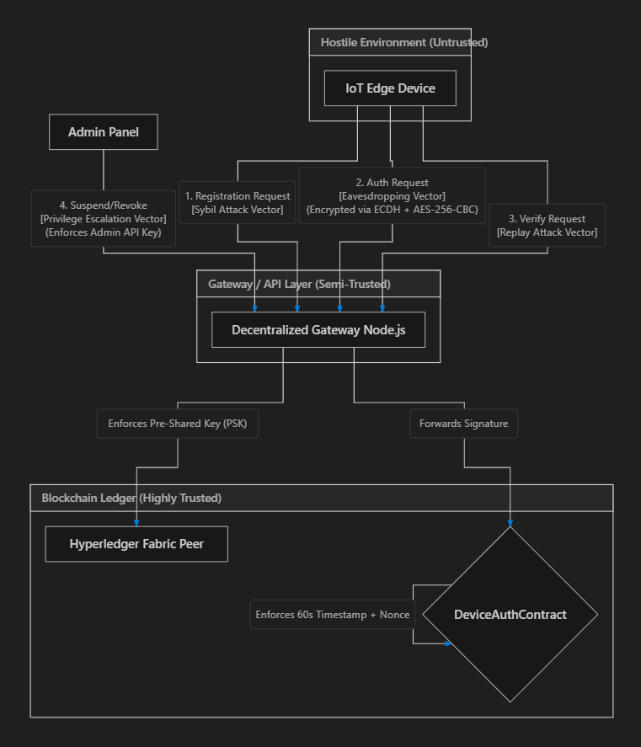
Figure 4. Threat Model and Trust Boundaries flowchart
Figure 4 takes these abstract security concepts and grounds them in a concrete data flow chart. It explicitly partitions the framework into three distinct zones: the Hostile Environment at the edge, the Semi-Trusted DMZ where our Node.js gateways sit, and the Highly Trusted Blockchain Ledger. The flowchart details the specific perimeter defenses imposed at each boundary. For instance, to stop attackers from flooding the network with fake device identities (a Sybil attack) from the hostile zone, the DMZ middleware boundary strictly enforces a Pre-Shared Key (PSK). In such a Hostile Environment, devices are vulnerable to physical tampering and network sniffing, which is why the eavesdropping attack vector is addressed using an ECDH and AES-256-CBC encrypted tunnel. The diagram also shows how the blockchain ledger acts as the final arbiter of truth, enforcing a 60-second timestamp window to mathematically neutralize Replay attacks. Finally, any privilege escalation attack vectors are handled by requiring an Admin API key for state-altering functions like suspending or revoking devices.

3.3 Cryptographic Challenge-Response Protocol
Simply connecting a device to a network is not enough, the network needs mathematical proof that this new device is who it claims to be. Inspired by other secure communication protocols, a cryptographic Challenge-Response Protocol is the mechanism we use to verify device identity without ever transmitting its private password over the air. The requested gateway issues a random, single-use "challenge" (a nonce) and the device must generate a valid "response" using its securely stored private key.
To prevent eavesdropping during this exchange, the system utilizes a strict Application-Layer Security tunnel. During the initial registration phase, the device and the gateway agree on an AES-256-CBC shared secret using an Elliptic Curve Diffie-Hellman (ECDH) key exchange.
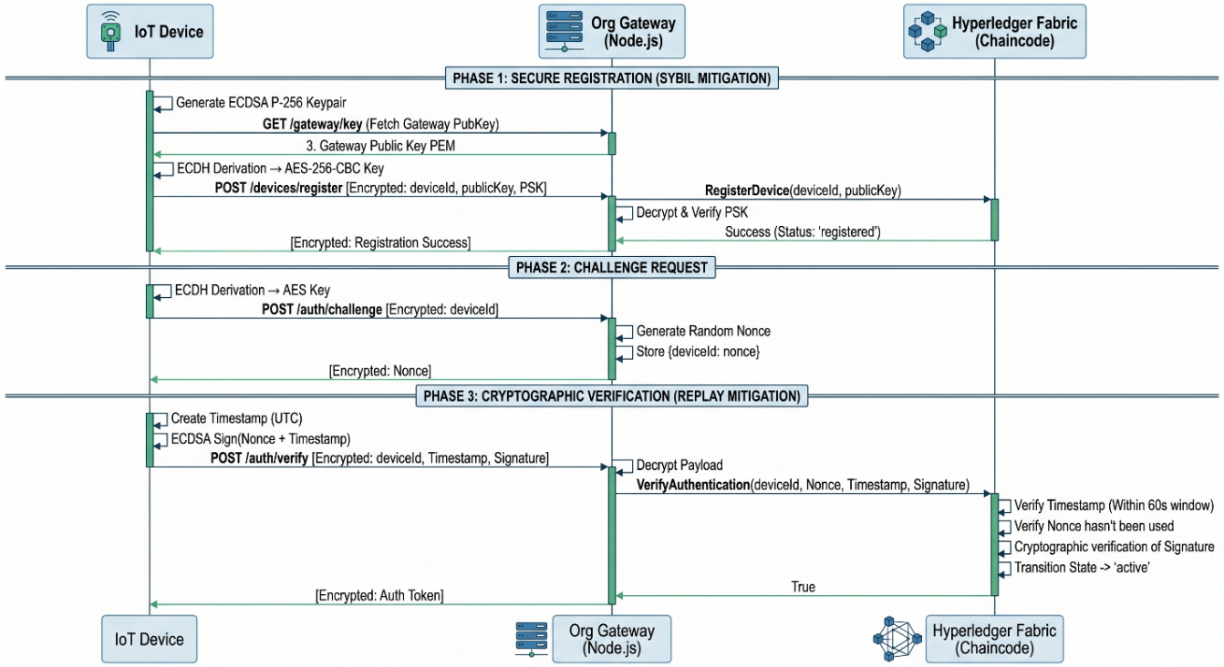
Figure 5. Authentication Sequence Diagram (with Application-Layer Security)
Because this protocol relies on strict chronological steps, Figure 5 breaks the process down into a sequence diagram. This visualizes the temporal handshake between the IoT device, the Gateway and the Fabric chaincode. The diagram above walks us through the three critical phases of device lifecycle management implemented in my project.
We start with Phase 1, where the device derives its unique AES symmetric key (the shared secret) and registers its public key on the blockchain. Notice how a pre-shared key (PSK), replacing a flashed or manufacturer key in our test scenario, is also necessary for the registration process to succeed (the Sybil attack prevention).
We then move to Phase 2, where the gateway issues the challenge nonce. This 32-byte nonce needs to be highly randomized, ideally the result of a non-deterministic process. For communication with the gateway, the device can simply use the shared AES key established during the registration process.
Finally, we arrive in Phase 3, where the device proves its identity by signing both the nonce and a UTC timestamp with its ECDSA secp256r1 private key. The gateway does not verify this signature, as it stores no public key. It simply decrypts the message, translates it into a gRPC call, and transmits it to the Fabric network, where the entire verification process happens through our deployed chaincode.
By mapping out these interactions, our sequence diagram clearly demonstrates how authentication is achieved without exposing sensitive keys to the larger network.

3.4 Chaincode Architecture and Chaincode Device Lifecycle
Once a device's identity is cryptographically verified, it requires further management. A smart contract, also known as chaincode in Fabric, is a distributed autonomous application that can automate security policies directly on the distributed ledger [20]. Thus, we define the "Chaincode Device Lifecycle" as the set of deterministic, coded rules that govern an edge node’s identity, operational status and trust, over time. In our blockchain context, a device's identity is not simply created or destroyed, it transitions through various operational states based on strict administrative actions or automated network triggers.
To enforce these rules, our blockchain system relies on the DeviceAuthContract, which functions as a decentralized state machine on Hyperledger Fabric’s ledger. Before exploring how a device moves between states, we must understand exactly what data is being stored.
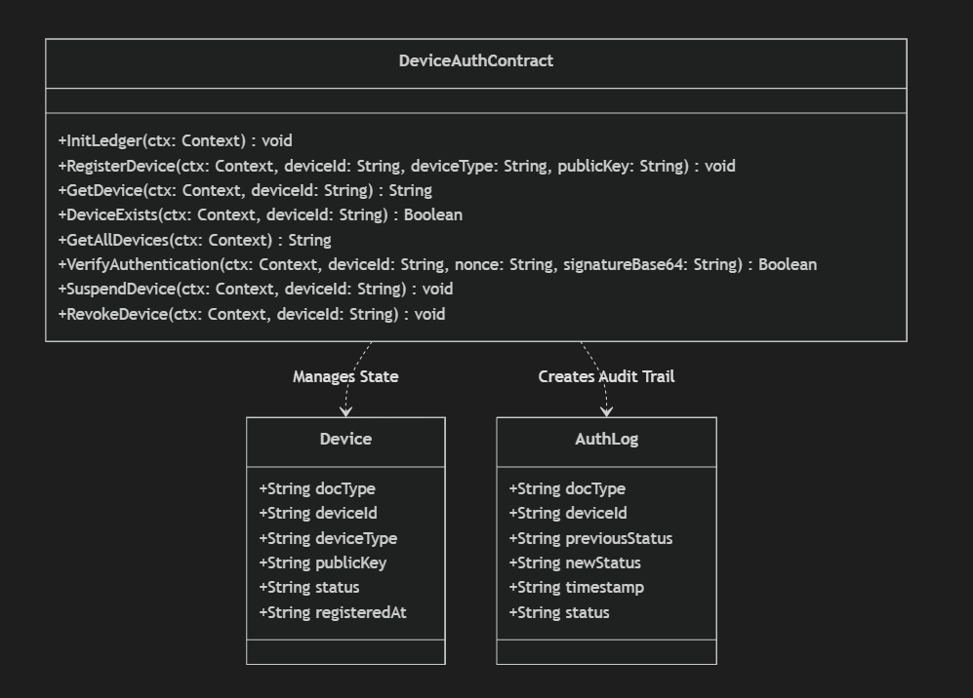
Figure 6. DeviceAuthContract chaincode Class Diagram
Figure 6 presents a UML Class Diagram detailing the specific data structures and methods encapsulated within our DeviceAuthContract chaincode. My model relies on two primary data structures: Device and AuthLog. The Device class represents the asset as it is saved in the CouchDB state database. Note how the ledger does not store any private keys! Instead, it securely stores the deviceId, publicKey, deviceType and the current operational status. The AuthLog class creates a separate, immutable audit trail every time a device changes its status, tracking the previousStatus, the newStatus and the exact timestamp of the transition.
The class diagram also lists the core executable methods exposed by the DeviceAuthContract. Functions like “InitLedger” and “GetDevice” handle state queries, while
“RegisterDevice” and “VerifyAuthentication” manage the automated cryptographic onboarding. Administrative functions like “SuspendDevice” and “RevokeDevice” are reserved exclusively for network governance.
This structural organization of my chaincode directly feeds into how it manages the device's operational lifecycle. Since every state change automatically generates an AuthLog entry, no single entity can arbitrarily alter a device's permissions without leaving a permanent footprint on the ledger.
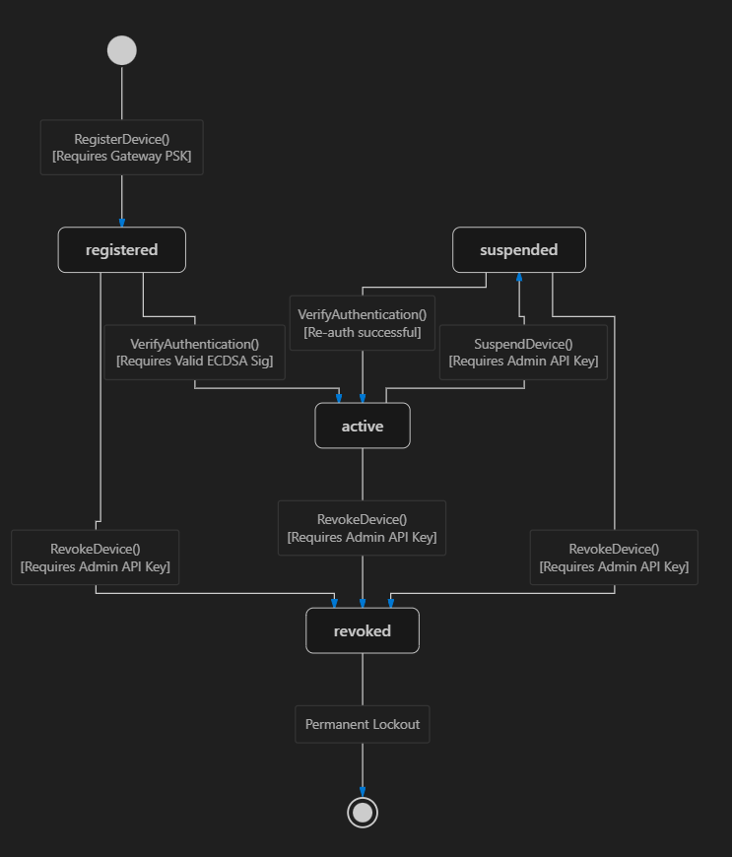
Figure 7. DeviceAuthContract chaincode Lifecycle state machine Diagram
This governance model is presented in Figure 7 through a state machine diagram. It maps out every valid transition any IoT device can make through my chaincode. As shown in the diagram, a device can only begin in a registered state, moving to active only when it passes the signature verification phase (it mathematically authenticates). However, in reality networks require some additional flexibility. If a network administrator notices an anomaly, like some unusual traffic coming from a particular device, they can trigger the “SuspendDevice” function. The diagram shows how this transitions the device into a suspended state, temporarily blocking its network access, while still safely preserving its identity on the ledger. If a device is definitively compromised, it can directly be pushed into a permanent revoked state. This diagram ultimately highlights the granular, enterprise-grade access control that permissioned ledgers offer over public alternatives.

Chapter 4: System Implementation

4.1 Hyperledger Fabric Setup
The backbone of this project’s decentralized authentication framework is built upon Hyperledger Fabric v2.x [8]. Unlike public ledgers that mostly rely on computationally expensive consensus mechanisms like Proof of Work (PoW), Fabric operates as a permissioned network. As a result, there is a certain “local” level of trust to build upon, as the network is built on the assumption of a multi-organizational environment where the organizations are known to each other. This allows Fabric’s network to employ a more efficient crash fault-tolerant Raft (etcdraft [22]) consensus mechanism and remove the need for a central Kafka cluster, which helps in fulfilling this project’s decentralization argument.
For this project, a Multi-Organization architecture was deployed featuring 2 organizations: Org1 and Org2.
To ensure the network was optimized for high-throughput IoT traffic, specific parameters were configured within the configtx.yaml file of the test network. The block-cutting criteria were also explicitly tuned as bellow:
# Batch Timeout: The amount of time to wait before creating a batch
BatchTimeout: 2s
# Batch Size: Controls the number of messages batched into a block
BatchSize:
# Max Message Count: The maximum number of messages to permit in a batch
MaxMessageCount: 10
# Absolute Max Bytes: The absolute maximum number of bytes allowed for
# the serialized messages in a batch.
AbsoluteMaxBytes: 99 MB
# Preferred Max Bytes: The preferred maximum number of bytes allowed for
# the serialized messages in a batch. A message larger than the preferred
# max bytes will result in a batch larger than preferred max bytes.
PreferredMaxBytes: 512 KB
# Organizations is the list of orgs which are defined as participants on
# the orderer side of the network

These parameters mean a new block is “cut” (like “minted” in Bitcoin) either every 2 seconds or as soon as 10 authentication requests are batched, ensuring rapid transaction finality for authenticating devices.
The core of my authentication logic, the DeviceAuthContract smart contract showcased in Figure 6, was implemented in TypeScript to leverage Node.js's native JSON handling (commands like JSON.stringify), which is described in the broader documentation at [14]. This smart contract implements and manages the finite state machine presented in Section 3.4, which enforces the 4 possible device states: registered, active, suspended, and revoked.

The lifecycle of an IoT device begins with the RegisterDevice() transaction. As depicted in the State Machine (Figure 7), the device is initially granted a registered status. My implementation explicitly prevents identity hijacking by verifying if the deviceId already exists before committing the created Device structure to the CouchDB state database:
@Transaction()
public async RegisterDevice(ctx: Context, deviceId: string, deviceType: string, publicKey: string): Promise<void> {
// 1. Check if the device already exists to prevent identity hijacking
const exists = await this.DeviceExists(ctx, deviceId);
if (exists) {
throw new Error(`The device ${deviceId} is already registered on the network.`);
}

// 2. Construct the device state object
const device: Device = {
docType: 'device',
deviceId,
deviceType,
publicKey,
status: 'registered',
registeredAt: ctx.stub.getTxID(),
};

// 3. Save to the ledger
// Note: For deterministic sorting in production, standard stringify is often replaced with deterministic-stringify
await ctx.stub.putState(deviceId, Buffer.from(JSON.stringify(device)));

// 4. Emit an event for the Node.js Middleware to catch
ctx.stub.setEvent('DeviceRegistered', Buffer.from(JSON.stringify({ deviceId, status: 'registered' })));
}

Once registered, the new IoT device must prove its identity via the VerifyAuthentication() transaction (the entire source code for this core function is available in Appendix A). When a device authenticates, the chaincode executes the cryptographic validation natively on the peer. To illustrate this, I present the following chaincode code snippet that enforces a strict 60-second time window by extracting the deterministic transaction timestamp directly from the ledger state ctx.stub.getTxTimestamp():
// 2.5 Replay Attack Protection (Nonce Cache & Deterministic Time Validation)
const nonceKey = `NONCE_${nonce}`;
const nonceExists = await ctx.stub.getState(nonceKey);
if (nonceExists && nonceExists.length > 0) {
throw new Error(`Replay Attack Detected: The nonce ${nonce} has already been used.`);
}

// Validate the device's timestamp is within the allowed window (limit: 60 seconds) of the transaction timestamp to prevent replay attacks with old signatures
const timestampObj = ctx.stub.getTxTimestamp();
let txSeconds = 0;
// The timestamp can be represented in different formats depending on the environment, so I handle both cases (number or Long)
if (timestampObj && timestampObj.seconds) {
txSeconds = (typeof timestampObj.seconds === 'number') ? timestampObj.seconds : ((timestampObj.seconds as any).low || (timestampObj.seconds as any).toNumber());
}
const txDate = new Date(txSeconds * 1000);
const deviceDate = new Date(deviceTimestampStr);
const timeDiff = Math.abs(txDate.getTime() - deviceDate.getTime());

// Reject if older than 60 seconds (60,000 ms)
if (timeDiff > 60000) {
throw new Error(`Signature Expired: The authentication payload is outside the valid 60-second time window. txDate: ${txDate}, deviceDate: ${deviceDate}`);
}

If the ECDSA secp256r1 signature is proven valid and the maximum time window is respected, the device transitions to the active status. To ensure we have total transparency and auditable state management inside Fabric network, this successful state transition automatically generates an immutable AuthLog entry on the ledger (as described in Figure 6). This guarantees that administrators can audit the exact lifecycle of any device without having to rely on a centralized database.
In the code bellow, I present this logging process, when a device successfully authenticates and changes its state to active on the ledger:
// 5. Audit Trail
// Generate a log entry on the ledger proving a successful authentication occurred
const auditLog = {
docType: 'authLog',
deviceId,
previousStatus,
newStatus: 'active',
timestamp: ctx.stub.getTxID(), // need this for the date to be deterministic across peers
status: 'SUCCESS'
};
const logId = `LOG_${deviceId}_${ctx.stub.getTxID()}`;
await ctx.stub.putState(logId, Buffer.from(JSON.stringify(auditLog)));

ctx.stub.setEvent('DeviceAuthenticated', Buffer.from(JSON.stringify({ deviceId, previousStatus, newStatus: 'active' })));

// 6. Mark Nonce as Used to prevent replay
await ctx.stub.putState(nonceKey, Buffer.from('USED'));

4.2 Dual-Protocol Middleware Gateways
To bridge the gap between the resource-constrained IoT devices and the complex gRPC requirements of the Hyperledger Fabric SDK, I developed a dual-protocol middleware gateway using Node.js. As discussed in subchapter 3.1 and illustrated in the High-Level System Architecture (Figure 2), this gateway operates as an intermediate Fog node. It buffers the heavy cryptographic processing away from the Edge Layer and handles the secure routing into the Fabric network.
To ensure seamless operation within the Multi-Organization architecture, the identity of the gateway is dynamically injected via environment variables. For instance, the env.org1 script bellow configures the Fog node to route transactions exclusively as Org1.
FABRIC_ORG=org1
FABRIC_MSP_ID=Org1MSP
FABRIC_PEER_ENDPOINT=localhost:7051
FABRIC_PEER_HOST=peer0.org1.example.com
PORT=3000
COAP_PORT=5683
A similar script can be used to route transactions to other peer organizations on the network, like Org2 (the env.org2 script).
Using this configuration, the fabricService.js script provisions a secure gRPC connection to the peer, utilizing TLS certificates to verify the connection. Once connected, the gateway relies on controllers.js to enforce application-layer security before any transaction even touches the blockchain. For example, to prevent Sybil attacks during the registration phase (as modeled in the Threat Model, subchapter 3.2), the controller requires a Pre-Shared Key (PSK):
// Validate Pre-Shared Key to prevent unauthorized registration (Sybil attack mitigation)
if (!psk || psk !== REGISTRATION_PSK) {
throw { status: 403, message: 'Registration denied: Invalid or missing Pre-Shared Key (PSK)' };
}
await fabricService.registerDevice(deviceId, deviceType, publicKey);
To accommodate different deployment environments, the gateway exposes two distinct API surfaces simultaneously (the full source code for the routing and server initialization can be found in Appendix B):
1. HTTP/JSON (Port 3000): A traditional REST API built with node’s Express.js framework. This serves as a reliable fallback for environments where UDP traffic is restricted or NAT routing is problematic.
2. CoAP/CBOR (Port 5683): A highly optimized, UDP-based endpoint utilizing the coap and cbor-x libraries. The Constrained Application Protocol (CoAP) significantly reduces packet overhead, making it the ideal transport layer for real-world IoT deployments [33].
The middleware's ability to seamlessly decode these binary payloads and route them to the Fabric SDK is demonstrated in the following snippet from the coapServer.js logic:
let payload = {};
if (req.payload && req.payload.length > 0) {
try {
payload = decode(req.payload);
} catch (err) {
console.error('CBOR decode error:', err);
res.code = '4.00'; // Bad Request
return res.end(encode({ error: 'Invalid CBOR payload' }));
}
}
// Route to Hyperledger Fabric SDK Controllers
if (method === 'POST' && url === '/api/v1/auth/verify') {
result = await controllers.verifyAuthentication(payload);
res.code = '2.05'; // Content
}

By running these gateways independently for Org1 and Org2, the framework achieves true decentralization. If the Org1 gateway crashes, devices can simply move to Org2 and authenticate against the exact same blockchain ledger. This is possible because the gateway is a thin, stateless proxy for the Fabric SDK by design. As an example, the backend was parameterized to use the same codebase to run both organizations, controlled entirely by the presented environment variables (the 2 env.org scripts). On the frontend, a selector toggle was added to target either gateway in real time.
To better view the near stateless nature of the gateways, we can use the following table:

Table 1. Component State Dependency
Component | State location | Gateway dependency
Device identities | Fabric ledger (world state) | None - reads from chain
Cryptographic verification | Chaincode on the peers | None - delegates to chain
Audit trail | Immutable ledger | None - written on chain
Challenge nonces | challengeStore (in-memory Map) | Only temporary state
Latency metrics | simulatorLatencies[] (in-memory) | Observability only

The only in-memory state is the transient nonce challenge (challengeStore), which is a short-lived value that exists only between the challenge and verify calls. There is no shared database between the gateways, the blockchain is our database. It is worth noting that this also means a device’s challenge and verify calls must hit the same gateway instance (session affinity), but this is not a large issue, since our nonces are temporary and this time window is very narrow and does not affect the overall decentralization. The nonce could be embedded directly into the Fabric ledger, as an alternative. Thus, we are protected from single points of failure as the gateways are easily replicable, and even if one gateway is compromised, any other inside the organization can be used to complete the authentication process.

4.3 The Simulation Strategy (Hardware vs. Software)
Evaluating an IoT framework requires proving both, that the cryptography can run on weak hardware and that the backend can scale to handle thousands of concurrent requests. To address this, I utilized a hybrid simulation strategy:

4.3.1 The QEMU ARM Emulator:
To verify my implementation’s feasibility on authentic, legacy hardware architectures, I utilized QEMU (Quick Emulator) [34] to boot a virtualized qemu-rpi-os-lite:buster-latest image. This Raspberry Pi OS perfectly emulates the instruction set of a constrained 32-bit Cortex-A series ARM processor [35]. The configuration file used to boot this emulator docker-compose-qemu.yml, together with the bash script qemu-setup.sh used to automate the deployment and execution of the simulation inside the virtual environment, can be found in Appendix C.
Inside the emulator, the client logic is driven by a custom Python script device_arm.py. Due to known limitations with QEMU's SLIRP UDP NAT, which consistently dropped CoAP responses during testing, this client communicates exclusively over the HTTP/JSON gateway endpoint. Furthermore, to capture true hardware constraints, the script offloads the heavy ECDH key agreement and AES-256-CBC encryption to the native openssl CLI tool. This proves that even older, constrained ARM hardware can successfully negotiate an application-layer secure tunnel and sign authentication nonces without crashing, as demonstrated by the following Python code section:
# 1. Generate ECDH key pair using openssl CLI
subprocess.check_call(['openssl', 'ecparam', '-name', 'prime256v1', '-genkey', '-noout', '-out', eph_key_file], stderr=subprocess.DEVNULL)
subprocess.check_call(['openssl', 'ec', '-in', eph_key_file, '-pubout', '-out', eph_pub_file], stderr=subprocess.DEVNULL)

with open(eph_pub_file, 'r') as f:
eph_pub_pem = f.read()

# 2. Derive shared secret
subprocess.check_call(['openssl', 'pkeyutl', '-derive', '-inkey', eph_key_file, '-peerkey', gw_pub_file, '-out', secret_file], stderr=subprocess.DEVNULL)

with open(secret_file, 'rb') as f:
secret = f.read()

# 3. Hash secret to get AES key
import hashlib
aes_key = hashlib.sha256(secret).digest()
aes_key_hex = binascii.hexlify(aes_key).decode('utf-8')

# 4. Generate IV and Encrypt
iv = os.urandom(16)
iv_hex = binascii.hexlify(iv).decode('utf-8')

subprocess.check_call(['openssl', 'enc', '-aes-256-cbc', '-K', aes_key_hex, '-iv', iv_hex, '-in', payload_file, '-out', encrypted_file], stderr=subprocess.DEVNULL)

As illustrated by the Python snippet above, the process strictly relies on the native OS capabilities. First, the ecparam command generates a temporary elliptic curve key pair. Second, pkeyutl derives the shared secret by combining the device's temporary private key with the gateway's static public key. Finally, this derived secret is hashed into an AES-256 key, which is used to securely encrypt the payload using Cipher Block Chaining (‘-aes-256-cbc’) before the HTTP POST request is dispatched. This explicitly proves that the cryptographic overhead modeled in Chapter 3.2 is entirely feasible on legacy hardware without requiring heavy third-party Python libraries.

4.3.2 The Docker Fleet:
While QEMU proves hardware feasibility, it cannot prove network scalability. To stress-test the Fabric ledger's throughput, I deployed a massive Docker container fleet [36] running on my x86 host architecture. The concurrent deployment configuration file for this fleet docker-compose.coap.yml is also detailed in Appendix C.
The fleet is orchestrated using device.js, a highly concurrent Node.js script. Unlike the ARM emulator, the Docker fleet leverages the CoAP/CBOR protocol by default, firing thousands of lightweight UDP packets at the gateways. To accomplish this, the script natively encodes JSON payloads into raw binary using cbor-x before transmitting them over UDP:
// Helper to send CoAP POST requests with CBOR payload
function coapPost(endpoint, data) {
return new Promise((resolve, reject) => {
const urlString = `${COAP_URL}/${endpoint}`;
const url = new URL(urlString);
const req = coap.request({
pathname: url.pathname,
host: url.hostname,
port: url.port || 5683,
method: 'POST'
});

const encodedPayload = encode(data);
const payloadBytes = encodedPayload.length;

{
//------ Response handling omitted for brevity
}

req.on('error', reject);
req.write(encodedPayload);
req.end();
});
}

As shown in the coapPost function, the Node.js Docker fleet avoids heavy HTTP overhead entirely. Before transmission, the encode(data) function compactly serializes the JSON request body into a raw binary CBOR format. This binary payload is then dispatched via the native UDP coap.request(). This process ensures that the payload size is significantly minimized, which is essential for preserving bandwidth and energy on constrained IoT networks.
To prevent the Fabric orderer from being immediately overwhelmed during a mass startup, the device.js script incorporates an intelligent exponential back-off and a random initialization delay (0-3 seconds). This fleet successfully proves that the dual-gateway architecture can process and commit simultaneous cryptographic authentications at scale without degrading our network’s integrity.

4.4 Browser Simulation and Administrative Dashboard
To visualize the real-time state of the decentralized network, a client-side Administrative Dashboard was developed using React and Vite [15].
Beyond purely administrative functions, the dashboard natively simulates the cryptographic behavior of an IoT device, as presented in Figure 3. Because modern browsers cannot access native OS libraries like OpenSSL (as QEMU does), the React application uses the readily available W3C WebCrypto API to execute ECDSA secp256r1 signatures natively within the browser engine. The following code snippet from App.jsx demonstrates how the browser signs the challenge nonce and timestamp before converting the IEEE P1363 signature into the ASN.1 DER format required by the Fabric chaincode:
// 3. Sign the nonce + timestamp with ECDSA SHA-256 using Web Crypto
addLog(`${deviceId} signing challenge nonce (ECDSA secp256r1)`, 'info');
const sigStart = performance.now();
const deviceTimestampStr = new Date().toISOString(); // Added Timestamp
const payloadString = nonce + deviceTimestampStr;
const nonceBytes = new TextEncoder().encode(payloadString);
const signatureP1363 = await window.crypto.subtle.sign(
{ name: 'ECDSA', hash: 'SHA-256' },
privateKey,
nonceBytes
);

// 4. Convert the IEEE P1363 signature to ASN.1 DER format (what Node's crypto.createVerify expects)
const derSignature = ieeeP1363ToDer(signatureP1363);
const signatureBase64 = arrayBufferToBase64(derSignature.buffer);
const sigEnd = performance.now();
const signingMs = Math.round(sigEnd - sigStart);

As demonstrated in the code, the simulation constructs the payload by concatenating the challenge nonce with the current ISO timestamp, ensuring the signature adheres to the strict 60 second validity window imposed by my chaincode. The window.crypto.subtle.sign method then generates an ECDSA signature over the SHA-256 hash of this payload. Crucially, because WebCrypto outputs signatures in the raw IEEE P1363 format, the frontend must manually convert this binary array into the ASN.1 DER format. This conversion is strictly required to ensure interoperability with the Node.js crypto library running on the backend middleware and the Hyperledger Fabric chaincode. Also, we can see how we use signingMs to compute the signature generation timing for the latency metrics.
The functional implementation of this dashboard, including the: gateway selector, live metric graphs, the authentication log queries, and the administrative device management functions (such as RevokeDevice, SuspendDevice, etc.) is best demonstrated visually bellow.
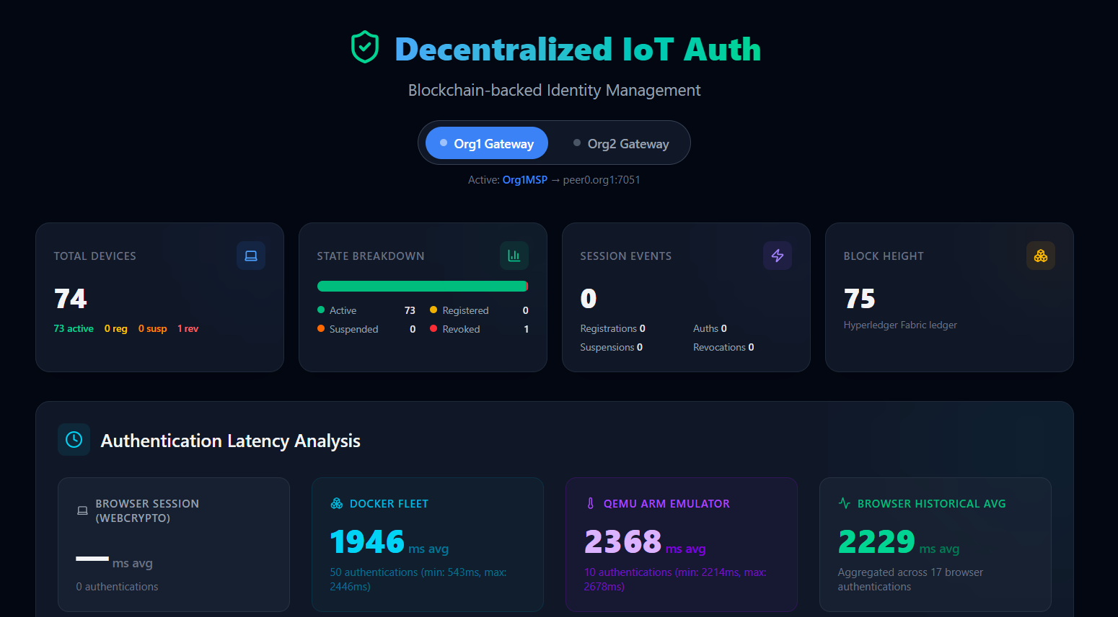
Figure 8. Frontend Administrative Dashboard
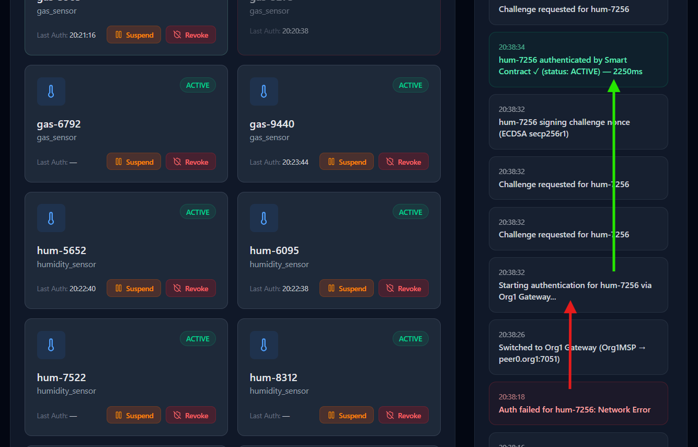
Figure 9. Frontend Device Status and Audit Logs
The dashboard presented in Figure 8 and Figure 9 connects to both the Org1 and Org2 middleware gateways, aggregating the ledger's state. It allows administrators to query the immutable AuthLog trails, view active device connections, and manually trigger state control functions such as SuspendDevice or RevokeDevice. By utilizing a lightweight frontend framework, the dashboard ensures that security administrators maintain a God's-eye view of the multi-organization network without adding unnecessary overhead to the blockchain peers.
In Figure 8 we observe how the Dashboard acts as a live window into the blockchain, showing us the current blockchain height (BH), the state breakdown of the devices registered on the blockchain, and the average latency metrics of our 3 simulation environments. It also includes other data analysis metrics that will be presented in the next chapter.
In Figure 9 we can see how individual devices are recorded on the blockchain, together with some state altering methods we can use to operate on them. In the Audit trail, on the right side, we also prove our system works as intended when a gateway fails or becomes unavailable. After the Org2 Gateway has failed, we switch to the Org1 Gateway and the hum-7256 device authenticates without a problem. Other core chaincode methods that manipulate devices are also recorded in this log.
The Administrative Dashboard also helps us with data collection, as it actively polls the Fabric chaincode for various metrics. The general system implementation included localized phase-timing hooks built directly into the Node.js middleware. By exposing a dedicated /metrics REST endpoint, the middleware precisely tracks the differences between the initiation of an authentication challenge and the final ledger commitment.

Chapter 5: Experimental Results and Performance Analysis

5.1 Evaluation Methodology
How you measured the data.

5.2 Cryptographic Overhead Analysis
Comparing x86 vs. ARM emulation (The 123ms vs 5ms signing time discussion). [Insert your Data Table here]

5.3 Network Scalability and Payload Efficiency
HTTP/JSON vs CoAP/CBOR overhead.

5.4 Resilience to Network Failures
Testing the Multi-Gateway setup and the Exponential Backoff mechanism.

Chapter 6: Conclusions and Future Work

6.1 Conclusion
Summarizing that decentralized trust is viable for legacy edge devices if designed correctly.

6.2 Future Work
Discussing Hardware TPMs, DTLS proxies, and Post-Quantum Cryptography.

References
[1] M. A. Khan and K. Salah, “IoT security: Review, blockchain solutions, and open challenges,” Future Gener. Comput. Syst., vol. 82, pp. 395–411, 2018.
[2] W. Wang and others, “A Survey on Consensus Mechanisms and Mining Strategy Management in Blockchain Networks,” IEEE Access, vol. 7, pp. 22328–22370, 2019.
[3] O. I. Abiodun and others, “A review on the security of the Internet of Things: Challenges and solutions,” Wirel. Pers. Commun., vol. 119, no. 3, pp. 2603–2637, 2021, doi: 10.1007/s11277-021-08348-9.
[4] D. Stefanescu and others, “A Systematic Literature Review of Lightweight Blockchain for IoT,” IEEE Access, vol. 10, pp. 126233–126252, 2022.
[5] S. Nakamoto, “Bitcoin: A Peer-to-Peer Electronic Cash System,” Decentralized Business Review, 2008. [Online]. Available: https://bitcoin.org/bitcoin.pdf
[6] G. Wood, “Ethereum: A secure decentralised generalised transaction ledger,” Ethereum Project Yellow Paper, 2014. [Online]. Available: https://ethereum.github.io/yellowpaper/paper.pdf
[7] Z. Zheng and others, “An Overview of Blockchain Technology: Architecture, Consensus, and Future Trends,” in 2017 IEEE International Congress on Big Data (BigData Congress), 2017, pp. 557–564.
[8] Hyperledger Foundation, “Hyperledger Fabric Documentation.” 2024. [Online]. Available: https://hyperledger-fabric.readthedocs.io/
[9] E. Androulaki and others, “Hyperledger Fabric: A distributed operating system for permissioned blockchains,” in Proceedings of the Thirteenth EuroSys Conference, 2018, pp. 1–15.
[10] National Institute of Standards and Technology, “Digital Signature Standard (DSS),” FIPS PUB 186-4, 2013. [Online]. Available: https://doi.org/10.6028/NIST.FIPS.186-4
[11] I. Ivan and C. Toma, Informatics Security Handbook, 1st ed. Bucharest, 2006. [Online]. Available: http://www.scribd.com/doc/63750074/Informatics-Security-Handbook-1st-Edition
[12] A. Famera, B. Hilger, S. Bhunia, and P. Heil, “Analyzing The Mirai IoT Botnet and Its Recent Variants: Satori, Mukashi, Moobot, and Sonic,” IEEE Access, 2021, [Online]. Available: https://arxiv.org/abs/2508.01909
[13] Z. Ahmed, S. M. Danish, H. K. Qureshi, and M. Lestas, “Protecting IoTs from Mirai Botnet Attacks using Blockchains,” in 2019 IEEE 24th International Workshop on Computer Aided Modeling and Design of Communication Links and Networks (CAMAD), 2019, pp. 1–6.
[14] Node.js Foundation, “Node.js Crypto Module Documentation.” 2024. [Online]. Available: https://nodejs.org/api/crypto.html
[15] Meta Platforms, Inc., “React: The library for web and native user interfaces.” 2024. [Online]. Available: https://react.dev/
[16] J. P. Ntayagabiri and others, “A Comprehensive Approach to Protocols and Security in Internet of Things Technology,” J. Comput. Theor. Appl., vol. 2, no. 3, pp. 324–341, 2024.
[17] W. Villegas-Ch and others, “Lightweight Blockchain for Authentication and Authorization in Resource-Constrained IoT Networks,” IEEE Access, vol. 13, pp. 48047–48067, 2025.
[18] M. A. Ferrag and others, “Blockchain Technologies for the Internet of Things: Research Issues and Challenges,” IEEE Internet Things J., vol. 6, no. 2, pp. 2188–2204, 2019.
[19] A. Dorri and others, “Blockchain for IoT security and privacy: The case study of a smart home,” in 2017 IEEE International Conference on Pervasive Computing and Communications Workshops (PerCom Workshops), 2017, pp. 608–613.
[20] K. Christidis and M. Devetsikiotis, “Blockchains and Smart Contracts for the Internet of Things,” IEEE Access, vol. 4, pp. 2292–2303, 2016.
[21] D. Ongaro and J. Ousterhout, “In search of an understandable consensus algorithm,” in 2014 USENIX Annual Technical Conference (USENIX ATC 14), Philadelphia, PA, 2014, pp. 305–319. [Online]. Available: https://www.usenix.org/system/files/conference/atc14/atc14-paper-ongaro.pdf
[22] Cloud Native Computing Foundation, “etcd: A distributed, reliable key-value store for the most critical data of a distributed system.” 2024. [Online]. Available: https://etcd.io/
[23] C. Gorenflo and others, “FastFabric: Scaling Hyperledger Fabric to 20,000 Transactions per Second,” ArXiv Prepr. ArXiv190100910, 2019, [Online]. Available: https://arxiv.org/abs/1901.00910
[24] J. Na and H. P. In, “S-Auth: Schnorr-enhanced Authentication Scheme for Security and Efficiency in Blockchain Web3.0,” IEEE Access, vol. 14, pp. 11455–11472, 2026.
[25] F. Bonomi, R. Milito, J. Zhu, and S. Addepalli, “Fog Computing and Its Role in the Internet of Things,” in Proceedings of the first edition of the MCC workshop on Mobile cloud computing, 2012, pp. 13–16.
[26] A. V. Dastjerdi, H. Gupta, R. N. Calheiros, S. K. Ghosh, and R. Buyya, “Fog Computing: Principles, Architectures, and Applications,” in Internet of Things: Principles and Paradigms, 2016, pp. 61–75. [Online]. Available: https://arxiv.org/abs/1601.02752
[27] S. Kumari and J. Thakur, “Performance and Scalability Analysis of Ethereum, Hyperledger Fabric, and IOTA,” Int. J. Eng. Res. Comput. Sci. Eng. IJERCSE, vol. 11, no. 12, 2024.
[28] J. P. Mehare and A. K. Gaikwad, “A Comparative Analysis of IoT-Based Blockchain Frameworks for Secure and Scalable Applications,” Int. J. Intell. Syst. Appl. Eng. IJISAE, 2023.
[29] S. Tuli and others, “FogBus: A Blockchain-based Lightweight Framework for Edge and Fog Computing,” J. Syst. Softw., vol. 154, pp. 144–166, 2019.
[30] Y. Liu and others, “LightChain: A Lightweight Blockchain System for Industrial Internet of Things,” IEEE Trans. Ind. Inform., vol. 15, no. 6, pp. 3571–3581, 2019.
[31] M. Zhao and others, “Blockchain-Based Lightweight Authentication Mechanisms for Industrial Internet of Things and Information Systems,” Int. J. Semantic Web Inf. Syst., vol. 20, no. 1, pp. 1–30, 2024.
[32] E. Bandara and others, “Tikiri—Towards a lightweight blockchain for IoT,” Future Gener. Comput. Syst., vol. 119, pp. 154–165, 2021.
[33] Z. Shelby and others, “The Constrained Application Protocol (CoAP).” Internet Engineering Task Force (IETF), RFC 7252, 2014. [Online]. Available: https://datatracker.ietf.org/doc/html/rfc7252
[34] QEMU, “QEMU Emulator User Documentation.” 2024. [Online]. Available: https://www.qemu.org/docs/master/
[35] ARM Ltd., “Cortex-A Series Processors.” 2024. [Online]. Available: https://developer.arm.com/Processors/
[36] Docker Inc., “Docker Engine overview.” 2024. [Online]. Available: https://docs.docker.com/engine/

Appendices

Appendix A: Smart Contract Source Code
The following code shows the authentication verification logic (VerifyAuthentication transaction) within my Fabric DeviceAuthContract. It enforces the 60-second deterministic timestamp window, checks for nonce reuse to prevent replay attacks, and natively validates the ECDSA secp256r1 signature:
// VerifyAuthentication is the core function that validates a device's authentication attempt.
@Transaction()
@Returns('boolean')
public async VerifyAuthentication(ctx: Context, deviceId: string, nonce: string, deviceTimestampStr: string, signatureBase64: string): Promise<boolean> {
// 1. Fetch the identity
const deviceString = await this.GetDevice(ctx, deviceId);
const device: Device = JSON.parse(deviceString);

// 2. Validate status : allow registered, active or suspended devices to authenticate
const allowedStates = ['registered', 'active', 'suspended'];
if (!allowedStates.includes(device.status)) {
throw new Error(`Authentication failed: Device ${deviceId} is marked as '${device.status}' and cannot be authenticated.`);
}

// 2.5 Replay Attack Protection (Nonce Cache & Deterministic Time Validation)
const nonceKey = `NONCE_${nonce}`;
const nonceExists = await ctx.stub.getState(nonceKey);
if (nonceExists && nonceExists.length > 0) {
throw new Error(`Replay Attack Detected: The nonce ${nonce} has already been used.`);
}

// Validate the device's timestamp is within the allowed window (limit: 60 seconds) of the transaction timestamp to prevent replay attacks with old signatures
const timestampObj = ctx.stub.getTxTimestamp();
let txSeconds = 0;
// The timestamp can be represented in different formats depending on the environment, so I handle both cases (number or Long)
if (timestampObj && timestampObj.seconds) {
txSeconds = (typeof timestampObj.seconds === 'number') ? timestampObj.seconds : ((timestampObj.seconds as any).low || (timestampObj.seconds as any).toNumber());
}
const txDate = new Date(txSeconds * 1000);
const deviceDate = new Date(deviceTimestampStr);
const timeDiff = Math.abs(txDate.getTime() - deviceDate.getTime());

// Reject if older than 60 seconds (60,000 ms)
if (timeDiff > 60000) {
throw new Error(`Signature Expired: The authentication payload is outside the valid 60-second time window. txDate: ${txDate}, deviceDate: ${deviceDate}`);
}

// 3. Cryptographic Verification
// We enforce SHA256 hashing to verify the secp256r1 ECDSA signature
const verify = crypto.createVerify('SHA256');
verify.update(nonce + deviceTimestampStr);
verify.end();

// Pass the stored public key and the device's signature to evaluate the math
const isValid = verify.verify(device.publicKey, signatureBase64, 'base64');

if (!isValid) {
throw new Error(`Authentication failed: Invalid cryptographic signature for device ${deviceId}.`);
}

// 4. Transition device status to 'active' upon successful verification
const previousStatus = device.status;
device.status = 'active';
await ctx.stub.putState(deviceId, Buffer.from(JSON.stringify(device)));

// 5. Audit Trail
// Generate a log entry on the ledger proving a successful authentication occurred
const auditLog = {
docType: 'authLog',
deviceId,
previousStatus,
newStatus: 'active',
timestamp: ctx.stub.getTxID(), // need this for the date to be deterministic across peers
status: 'SUCCESS'
};
const logId = `LOG_${deviceId}_${ctx.stub.getTxID()}`;
await ctx.stub.putState(logId, Buffer.from(JSON.stringify(auditLog)));

ctx.stub.setEvent('DeviceAuthenticated', Buffer.from(JSON.stringify({ deviceId, previousStatus, newStatus: 'active' })));

// 6. Mark Nonce as Used to prevent replay
await ctx.stub.putState(nonceKey, Buffer.from('USED'));

return true;
}

Appendix B: API Routes and Middleware Logic
The code sections presented in this Appendix represent the initialization and routing logic for the dual-protocol middleware gateway.
The app.js code bellow shows the Express Server Setup for the IoT Authentication Gateway.
It sets up the Express Server backend for our Application, by initializing the connection to the Hyperledger Fabric network and defining the API routes for handling frontend requests.
The server listens on the 2 ports (3000 – HTTP, 5683 – COAP) and includes error handling for cases like unhandled promise rejections. By using CORS, we allow the frontend application to communicate with this backend server without cross-origin issues.
const express = require('express');
const cors = require('cors');
const { initFabric } = require('./fabricService');
const routes = require('./routes');
const { startCoapServer } = require('./coapServer');

const app = express();
const PORT = process.env.PORT || 3000;
const COAP_PORT = parseInt(process.env.COAP_PORT, 10) || 5683;

app.use(cors());
app.use(express.json());

app.use('/api/v1', routes);

// this async function initializes the connection to the Hyperledger Fabric network before starting the Express server.
async function startServer() {
console.log('Initializing Fabric connections...');
await initFabric();
require('./cryptoHelper').init();

// server listens on port 3000 and binds to all network interfaces
const server = app.listen(PORT, '0.0.0.0', () => {
console.log(`Backend Server listening on port ${PORT} (0.0.0.0)`);
});

// Start the CoAP server for IoT devices
startCoapServer(COAP_PORT);

console.log(`Gateway identity: ${process.env.FABRIC_MSP_ID || 'Org1MSP'} | HTTP :${PORT} | CoAP :${COAP_PORT}`);

// Keep the process alive — the Fabric gRPC client unrefs internal sockets
// which can cause Node's event loop to drain and the process to exit prematurely
const keepAlive = setInterval(() => {}, 1 << 30); // ~12 days
server.on('close', () => clearInterval(keepAlive));
}

process.on('uncaughtException', (err) => {
console.error('UNCAUGHT EXCEPTION:', err);
});
process.on('unhandledRejection', (reason, promise) => {
console.error('UNHANDLED REJECTION:', reason);
});
process.on('exit', (code) => {
console.log(`Process exiting with code ${code}`);
});

startServer();

The coapServer.js code bellow demonstrates how the Node.js middleware intercepts UDP CoAP requests, decodes the CBOR payload and routes the request to the Hyperledger Fabric SDK controllers.
The server listens for requests from IoT devices, processes these requests, and interacts with the Fabric chaincode to manage device credentials and their authentication state. This CoAP server uses CBOR for binary encoding of payloads, which is better than JSON for constrained IoT devices.
const coap = require('coap');
const { encode, decode } = require('cbor-x');
const controllers = require('./controllers');

function startCoapServer(port = 5683) {
const server = coap.createServer();

server.on('request', async (req, res) => {
// CoAP request method (for 'POST' and 'GET')
const method = req.method;
// The URL path
const url = req.url.split('?')[0];

console.log(`[CoAP Server] Received ${method} request for ${url} from ${req.rsinfo.address}:${req.rsinfo.port}`);

// Note on Security (DTLS / CoAPS):
// In a production environment, this server should use CoAPS (CoAP over DTLS)
// to encrypt the payload and prevent eavesdropping or tampering.
// Currently, standard Node.js CoAP libraries do not natively support production-ready DTLS.
// Typically, we would use an external proxy like Eclipse Californium or an Nginx/HAProxy layer
// to terminate the DTLS connection and forward plain CoAP to this Node.js instance.

let payload = {};
// Decode the CBOR payload if it exists. We expect the payload to be a CBOR-encoded object containing the necessary fields for each endpoint.
if (req.payload && req.payload.length > 0) {
try {
payload = decode(req.payload);
} catch (err) {
console.error('CBOR decode error:', err);
res.code = '4.00'; // Bad Request
return res.end(encode({ error: 'Invalid CBOR payload' }));
}
}

// Route the request to the appropriate controller function based on the method and URL path.
try {
let result;
if (method === 'GET' && url === '/api/v1/gateway/key') {
result = await controllers.getGatewayKey();
res.code = '2.05'; // Content
} else if (method === 'POST' && url === '/api/v1/devices/register') {
result = await controllers.registerDevice(payload);
res.code = '2.01'; // Created
} else if (method === 'POST' && url === '/api/v1/auth/challenge') {
result = await controllers.requestChallenge(payload);
res.code = '2.05'; // Content
} else if (method === 'POST' && url === '/api/v1/auth/verify') {
result = await controllers.verifyAuthentication(payload);
res.code = '2.05'; // Content
} else if (method === 'POST' && url === '/api/v1/metrics/latency') {
result = controllers.recordLatency(payload);
res.code = '2.01'; // Created
} else {
res.code = '4.04'; // Not Found
console.log(`[CoAP Server] Endpoint not found: ${url}`);
return res.end(encode({ error: 'Endpoint not found' }));
}

console.log(`[CoAP Server] Sending response for ${url} with code ${res.code}`);
res.end(encode(result));

} catch (error) {
console.error(`CoAP Error [${method} ${url}]:`, error);
const status = error.status || 500;
// Map HTTP status codes to CoAP status codes roughly
if (status === 400) res.code = '4.00'; // Bad Request
else if (status === 401) res.code = '4.01'; // Unauthorized
else if (status === 403) res.code = '4.03'; // Forbidden
else if (status === 404) res.code = '4.04'; // Not Found
else res.code = '5.00'; // Internal Server Error

res.end(encode({ error: error.message || 'Internal error' }));
}
});

server.listen(port, () => {
console.log(`CoAP Gateway listening on UDP port ${port}`);
});

return server;
}

Appendix C: Emulation Configuration
The following configuration files define the hardware and software simulation environments used to evaluate the authentication framework.
- The docker-compose-qemu.yml (Hardware Emulation)
This file boots a full Raspberry Pi OS inside QEMU to emulate a constrained 32-bit ARM processor.
# QEMU ARM Emulator for hardware-accurate IoT authentication latency testing.
# This boots a full Raspberry Pi OS (Lite) inside QEMU, emulating an ARM processor.

# Usage: docker-compose -f docker-compose-qemu.yml up -d
# Then run the setup script to deploy and execute the simulator: bash qemu-setup.sh

services:
qemu-arm:
image: critoma/qemu-rpi-os-lite:buster-latest
container_name: qemu-arm-simulator
ports:
- "5022:5022"
restart: unless-stopped

- The qemu-setup.sh (Automated SSH Deployment Script)
This bash script automatically resolves the QEMU host IP, establishes an SSH connection to the emulated Raspberry Pi OS, copies the Python simulator, and executes the authentication tests.
#!/bin/bash
# Prerequisites:
# 1. The QEMU container must be running:
# docker-compose -f docker-compose-qemu.yml up -d
# 2. Wait ~30-60 seconds for the emulated OS to fully boot before running this.
# 3. sshpass must be installed (sudo apt install sshpass) to automate SSH login.
#
# Usage:
# bash qemu-setup.sh [number_of_runs]
# Example: bash qemu-setup.sh 5 (runs 5 sequential authentications)
# -----------------------------------------------------------------------------

QEMU_HOST="localhost"
QEMU_PORT="5022"
QEMU_USER="pi"
QEMU_PASS="raspberry"
NUM_RUNS="${1:-1}"

# Determine the host IP that the QEMU VM can use to reach our backend.
# You can override this manually: HOST_IP=192.168.1.100 bash qemu-setup.sh
if [ -z "$HOST_IP" ]; then
# Method 1: grep /etc/hosts inside the Docker container
HOST_IP=$(docker exec qemu-arm-simulator grep host.docker.internal /etc/hosts 2>/dev/null | awk '{print $1}')
fi
if [ -z "$HOST_IP" ]; then
# Method 2: resolve via ping inside the Docker container
HOST_IP=$(docker exec qemu-arm-simulator sh -c "ping -c1 -W1 host.docker.internal 2>/dev/null" | grep -oE '([0-9]{1,3}\.){3}[0-9]{1,3}' | head -1)
fi
if [ -z "$HOST_IP" ]; then
# Method 3: QEMU default gateway (last resort)
HOST_IP="10.0.2.2"
echo "WARNING: Could not auto-detect host IP. Falling back to ${HOST_IP}."
echo "If this fails, re-run with: HOST_IP=<your-windows-ip> bash qemu-setup.sh"
fi

SSH_OPTS="-o StrictHostKeyChecking=no -o UserKnownHostsFile=/dev/null -o LogLevel=ERROR -p ${QEMU_PORT}"
SCP_OPTS="-o StrictHostKeyChecking=no -o UserKnownHostsFile=/dev/null -o LogLevel=ERROR -P ${QEMU_PORT}"

echo "=========================================="
echo "QEMU ARM Simulator Setup"
echo "=========================================="
echo " Host: ${QEMU_HOST}:${QEMU_PORT}"
echo " Host IP: ${HOST_IP} (for backend access)"
echo " Runs: ${NUM_RUNS}"
echo ""

# Step 1: Wait for SSH to become available
echo "[1/5] Waiting for QEMU SSH to become available..."
MAX_RETRIES=30
RETRY=0
until sshpass -p "${QEMU_PASS}" ssh ${SSH_OPTS} ${QEMU_USER}@${QEMU_HOST} "echo 'SSH ready'" 2>/dev/null; do
RETRY=$((RETRY + 1))
if [ $RETRY -ge $MAX_RETRIES ]; then
echo "ERROR: Could not connect to QEMU VM after ${MAX_RETRIES} attempts."
echo "Make sure the container is running: docker-compose -f docker-compose-qemu.yml up -d"
echo "And wait at least 30-60 seconds for the OS to boot."
exit 1
fi
echo " Attempt ${RETRY}/${MAX_RETRIES} - waiting 5s..."
sleep 5
done
echo " SSH connection established!"
echo ""

# Step 2: Copy the Python simulator to the QEMU VM
echo "[2/4] Copying simulator files to ARM emulator..."
sshpass -p "${QEMU_PASS}" ssh ${SSH_OPTS} ${QEMU_USER}@${QEMU_HOST} "mkdir -p ~/simulator"
sshpass -p "${QEMU_PASS}" scp ${SCP_OPTS} device_arm.py ${QEMU_USER}@${QEMU_HOST}:~/simulator/
echo " Files copied successfully!"
echo ""

# Step 3: Run the simulator
echo "[3/3] Running ${NUM_RUNS} authentication(s) from ARM emulator..."
echo " Testing connectivity to backend at ${HOST_IP}:3000..."
sshpass -p "${QEMU_PASS}" ssh ${SSH_OPTS} ${QEMU_USER}@${QEMU_HOST} \
"curl -s --connect-timeout 5 http://${HOST_IP}:3000/api/v1/network/blockHeight && echo ' Success: Backend reachable!' || echo ' Failure: Cannot reach backend at ${HOST_IP}:3000'"
echo "=========================================="

for i in $(seq 1 ${NUM_RUNS}); do
echo ""
echo "--- Run ${i}/${NUM_RUNS} ---"
sshpass -p "${QEMU_PASS}" ssh ${SSH_OPTS} ${QEMU_USER}@${QEMU_HOST} \
"cd ~/simulator && SOURCE=qemu API_URL=http://${HOST_IP}:3000/api/v1 python3 device_arm.py 2>&1"

# I'll enforce a small delay between runs to avoid deviceId collisions
if [ $i -lt ${NUM_RUNS} ]; then
sleep 2
fi
done

echo ""
echo "=========================================="
echo "QEMU ARM simulation complete!"
echo "Check the frontend dashboard for the QEMU latency metrics."
echo "=========================================="

- The docker-compose.coap.yml (Mass Fleet Simulation)
This file is utilized to scale the Node.js Docker Fleet. It relies on the host's internal gateway to route lightweight UDP (CoAP) packets directly to the Windows-native middleware.
# CoAP/CBOR transport variant for the IoT simulator fleet.
# Requires the backend to run on Windows-native Node.js (not WSL)
# so that Docker containers can reach the UDP port directly.
#
# Prerequisites:
# .\startGateway.ps1 (we need to start the Org1 backend on Windows)
#
# Usage:
# docker-compose -f docker-compose.coap.yml up --build --scale sensor=5
#
# For Org2 gateway (CoAP port 5684):
# $env:COAP_GW_PORT="5684" (set up port) -> docker-compose -f docker-compose.coap.yml up --build --scale sensor=5

services:
sensor:
build: .
extra_hosts:
- "host.docker.internal:host-gateway"
environment:
# CoAP transport (UDP) — requires Windows-native backend (not WSL)
- COAP_URL=coap://host.docker.internal:${COAP_GW_PORT:-5683}/api/v1
# DEVICE_ID and DEVICE_TYPE are intentionally NOT set here.
# Each container will auto-generate a unique ID from its hostname
# and randomly pick a sensor type, enabling true concurrent scaling.

